Earthquake detector
A
PROJECT REPORT
SUBMITTED TO

SCHOOL OF COMPUTER SCIENCE & ENGINEERING,
LOVELY PROFESSIONAL UNIVERSITY,
PHAGWARA (INDIA)

IN PARTIAL FULFILLMENT OF THE REQUIREMENTS
FOR THE END TERM PROJECT
IN
BASIC ELECTRICAL AND ELECTRONICS ENGINEERING LABORATORY

SUBMITTED BY:

NAME OF THE STUDENT | REG. NUMBER | ROLL NUMBER | Domain Knowledge / Methodology (20) | Ergonomics/ Innovations (10) | Individual and team contribution (10) | Presentation skills  [20] | Viva Voce  [20] | Project Report  [20]
Shreeyansh janu | 12419027 | 56
Kartikey sengar | 12405305 | 62
Mohamed Hassan Abdikarin | 12412448 | 48
Smit Kumar Das | 12409850 | 45

SUPERVISED BY: Dr Anila Dhingra

DEPARTMENT OF ELECTRONICS AND COMMUNICATION ENGINEERING
LOVELY PROFESSIONAL UNIVERSITY
APRIL, 2025.
Earthquake detector

1. Introduction
Earthquakes are one of the most devastating natural disasters that cause significant damage to infrastructure and result in the loss of lives. Timely detection and alerts can help reduce the damage and improve emergency response. This paper introduces a low-cost earthquake detector using sensors, microcontrollers, and real-time notification mechanisms to aid in preparedness and safety
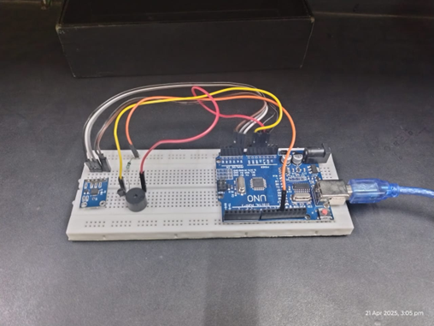
Fig 1 Earthquake detector using ardunio

2. earthquake detector structure

⬆ Sensors
  - Accelerometer (e.g.,
  - ADXL335 or MPU6050) to detect vibrations or motion in X, Y, Z directions.

⬆ ADC (Analog to Digital Converter) and Sensor Circuit
  - If using analog accelerometer: Signal converted to digital via Arduino's in-built ADC.
  - Proper connections with voltage dividers or filters if needed.
  - ⬆ Processor - Arduino Uno/Nano used to process input from the accelerometer. - Compares vibration data against threshold values.

⬆ Driver
  - Transistor (e.g., BC547 or 2N2222) used to drive the output device (buzzer, LED, GSM module, etc.).

⬆ Chassis and Body Structure
  - Compact platform to hold Arduino, accelerometer, power module, and output system. - Should be vibration-isolated or mounted firmly.

⬆ Power Supply (5V / 12V DC)
  - - 5V for Arduino and sensors. - 12V for relays, GSM modules, or larger actuators (if used). - Can use adapter, battery + regulator (7805), or USB power.

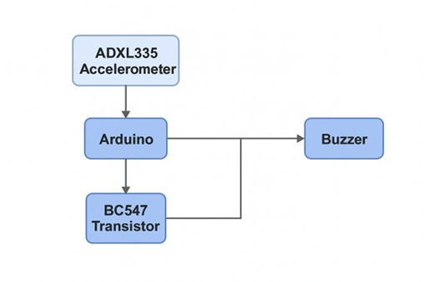
Fig 2 Block diagram

3 components and price
- Arduino with USB cable



- Adxl335 module 3 axis analog output accelometer


- Buzzer
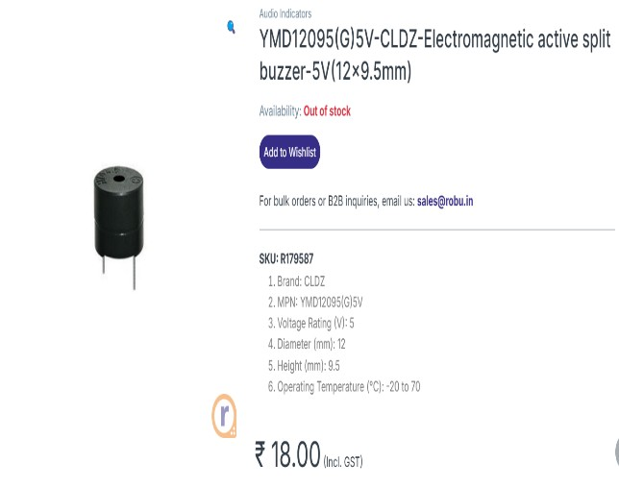

- BC547 transistor
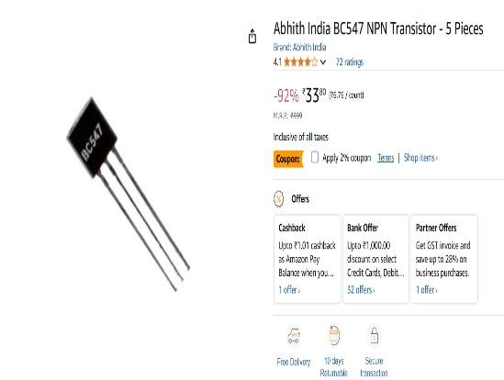

- I k ohm resistor



- Breadboard


4 use and functionality of each component

- Ardunio

The Arduino acts as the brain of the system. It continuously reads the analog signals from the ADXL335 accelerometer, which detects vibrations or movements on the X, Y, and Z axes. The Arduino processes this data in real-time and checks if the vibration level crosses a pre-set threshold that indicates an earthquake- like motion. If it does, the Arduino sends a signal to the BC457 transistor to activate the buzzer, giving an instant warning alert.

- ADXL355 accelerometer
The ADXL335 accelerometer is used to detect vibrations or movements in three directions— X, Y, and Z axes. It converts these physical movements into analog voltage signals, which are then sent to the Arduino. When the accelerometer senses sudden changes in acceleration (like during an earthquake), these signals help the Arduino determine whether the motion is strong enough to trigger the buzzer alarm.

- Transistor
The BC457 transistor is used as an electronic switch in the circuit. It is connected between the Arduino and the buzzer. When the Arduino detects an earthquake-like vibration, it sends a small current to the base of the transistor. This allows a larger current to flow from the collector to the emitter, activating the buzzer. Without the transistor, the Arduino might not be able to provide enough current to power the buzzer directly.

- Buzzer
The buzzer serves as the alert system in the project. When the Arduino detects unusual vibrations through the accelerometer and activates the transistor, the buzzer turns on and produces a loud sound. This sound acts as an immediate warning signal to alert people nearby about possible earthquake activity.

- 1K ohm resistor
The 1 kΩ resistor is used to limit the current flowing into the base of the BC457 transistor from the Arduino. This protects both the transistor and the Arduino pin from excess current. It ensures that the transistor switches properly without drawing too much current from the microcontroller.

5. circuit diagram

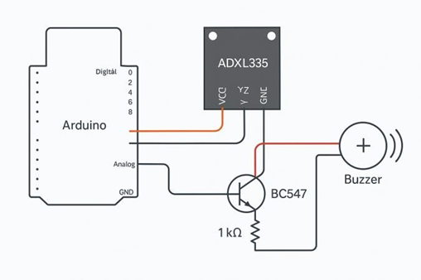

Fig 3 circuit diagram
- Step 1: Powering the Circuit
- Connect VCC of the ADXL335 to the 5V pin of the Arduino.
- Connect GND of the ADXL335 to GND on Arduino.
- This powers the accelerometer.

- Step 2: Reading Motion Data
- Connect the X, Y, Z output pins of the ADXL335 to Arduino analog pins (e.g., A0, A1, A2).
- These analog pins will read the acceleration data from the sensor in real time

- Step 3: Motion Detection Logic
- In the Arduino code, calculate the change in acceleration using the X, Y, Z values.
- If a sudden spike is detected (which indicates a tremor), the Arduino will output a HIGH signal to trigger the alert system.
- Step 4: Controlling the Buzzer with Transistor
- The buzzer is connected to the collector of the BC457 transistor.
- The emitter of the transistor goes to GND.
- The base of the transistor is connected to a digital pin on the Arduino (e.g., D9) through a 1 kΩ resistor.
- Step 5: Role of the 1 kΩ Resistor
- The 1 kΩ resistor limits the current flowing from the Arduino to the base of the transistor.
- This protects the Arduino and the transistor from excessive current.

- Step 6: Triggering the Alert
- When the Arduino detects strong movement, it sends a HIGH signal to the transistor’s base.
- This allows current to flow from collector to emitter, activating the buzzer.

7. Results and Discussion
The proposed earthquake detector was tested under controlled vibrational stimuli. It successfully detected threshold-level tremors and activated alerts within seconds. The system is cost-effective and suitable for deployment in schools, homes, and workplaces. Further enhancements can include cloud connectivity and integration with emergency services.

Identify applicable funding agency here. If none, delete this text box.

